Music proposal – Jenna & Zac – 21 March 2021
Your wedding is an intimate reflection of you and as such requires musical and creative attention. To authentically convey that feeling to the guests sharing in this momentous day, your musical input is invaluable.
Over the next months, we’ll be working with you on your wedding soundtrack. Building on our experience of what works and what doesn’t, we’ll guide you in the repertoire selection process from guest arrivals to closing song.
Most of the suggested acts below are open to learning new repertoire, so if you’ve got something specific in mind, let us know. While we’ll try to our best to accommodate you, we’ll also be honest when we feel something won’t work musically or is not possible.
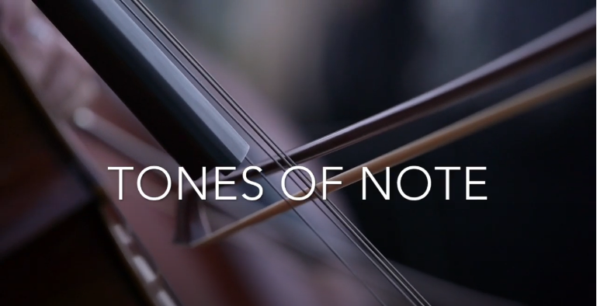

Pre-drinks: A DJ is a good alternative to a live performer for pre-drinks, with the music during this period setting the tone for the rest of the night. Musically speaking, DJs have a broader range of styles and songs to choose from, allowing them to take the music where the guests want it to go. Ultimately this set must be upbeat, featuring songs that appeal to the majority of your guests while also representing your musical preferences.
This is achieved by playing a mix of classics from soul, jazz, and current popular music. To find out which songs from those genres most resonate, we’ve included a 90-minute sampler below. Please give it a listen and send us your feedback. We’ll use that to curate the set.
Rus Nerwich - Playlist Sampler

Dinner: Option One
Rus Nerwich to DJ during dinner, facilitating flow around speeches.

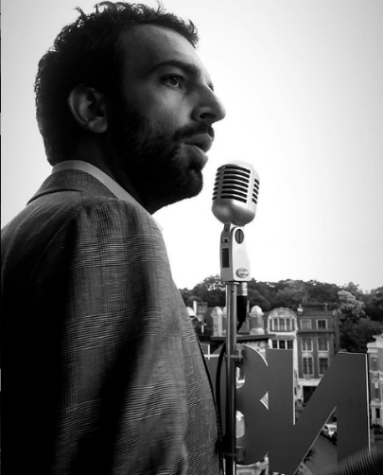
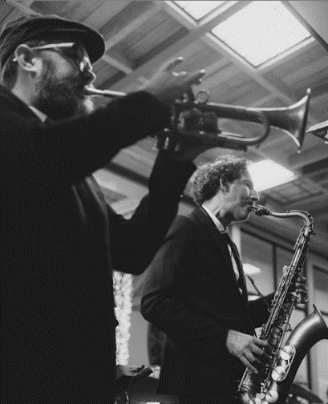
Dinner: Option Two
As the doors to the reception area are opened and the dinner and dance area are revealed, guests are greeted by Nathan Ambach and a 4-piece jazz quartet.
Over the course of dinner, the set will feature instrumental easy-listening jazz standards as well as crooner-style favourites.

Dance: Vocalists Nathan Ambach leads this 5-piece band including keys, bass, saxophone and drums to perform high-energy dance set opening the dancefloor. Touring and performing together for the last 6 years, Rus Nerwich and Nathan Ambach (N8N) have developed an electric onstage chemistry, offering clients an all-inclusive musical solution.
Both Nathan and Rus bring together 20 years of musical and performance experience. From world-class live performances of quintessential classics covering soul, funk, blues, pop and jazz to a dance till you can’t dance no more DJ set, you are guaranteed one of the greatest parties of your life!

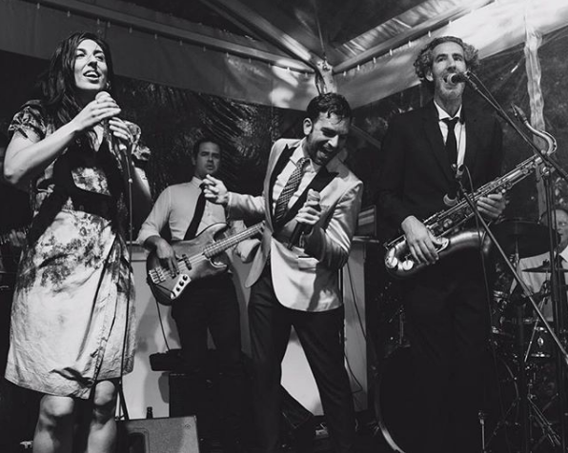

For more videos of the band’s past performances, please see the following links:

Instagram - Starlight Band - Prince - Kiss
Instagram - Starlight Band - Prince - Kiss (2)

Party: Straight from the band’s last song, we transition into the party set which will feature one of the following DJs.
Option one: DJ Colin Sher
An experienced and versatile DJ, Colin has performed at many of Cape Town's top clubs and parties. Some notable highlights include being the official DJ for the Coca-Cola pre-game events in Cape Town during the 2010 Soccer World Cup and performing at Trinity for the official U2, Coldplay and Kings of Leon afterparties. He’s also been a resident and guest DJ at many clubs in Cape Town over the years, such as St Yves, Tiger Tiger, Trinity, La Roi, Affinity, 91, The Grand and many more.
DJ Colin Sher - Promo video
DJ Colin Sher ft. Jimmy Nevis
Option two: DJ Nathan Ambach
In 2006, in his hometown of Antwerp, Nathan launched the nightlife series: The Love Below as ‘Your Monthly Rendezvous with Soul’, where he is still the resident DJ + promoter of funky music worldwide!
He’s DJ’d alongside Mark Ronson at the WMC in Miami and played at the Love Below with DJ Jazzy Jeff (The Fresh Prince), DJ Premier, DJ Maseo (De La Soul), and DJ Rashida – the official tour DJ of Prince and Bruno Mars and DJ'd sets in clubs and events around Europe, America, Asia, Africa and the Middle East.
His Spotify playlists and online mixtapes represent his funky style, championing soulful music with great grooves and party hooks. For over 20 years, N8N has been rocking the business from BBQs to Bar-Mitzvahs!
N8N - The DJ Side of the Story

